FOR IMMEDIATE RELEASE CONTACT: Kim Ina
swc@swcfoundation.org
(415) 566-3487

SPORTS FOR THE WORLD’S CHILDREN TO HOST 12TH ANNUAL
“THEY ARE WORTHY” BENEFIT SOFTBALL TOURNAMENT

SAN FRANCISCO, May 15, 2009 – The Sports for the World’s Children Foundation (SWC) will host its 12th annual “They Are Worthy” benefit softball tournament the weekend of July 18 & 19 at Westlake Park in Daly City. Format will be round robin and/or double elimination for the coed upper and lower divisions, and men’s D/DD/C divisions, depending on final number of entries. Participants are encouraged to bring gently used and new sports equipment to support their youth programs locally and abroad. All donated equipment and proceeds from the tournament go to providing kids (and communities and schools) with much needed sports equipment, facilities, skills clinics, and mentoring programs. Equipment needed includes baseballs, bases, basketballs, bats, batting gloves, catchers' gear, Frisbees, hats, mitts, soccer balls, sports trading cards, sports uniforms (at least five alike), volleyballs, volleyball nets, etc. Entry forms can be found at www.swcfoundation.org.

Last year a total of 18 teams participated in the four divisions of the tournament, and participants donated hundreds of pounds of sports equipment, including 144 brand new basketballs. The equipment was later transported to communities and programs in need through SWC’s “Communities Play” equipment distribution program. Most recently, SWC provided some much needed equipment to help support the Special Olympics Schools Partnership Program, a partnership between the Special Olympics of Northern California and the San Francisco Unified School District. The program is designed to give students with special needs an opportunity to participate in TEAM sports. This unique partnership allows the entire program to be offered at no expense to the students, teachers, or individual schools. Their Track and Field Meet at Kezar Stadium concluded today.

[ Special Olympics Schools Partnership Program photo(s) coming soon! ]

CONTINUED…
SWC’s next volunteer trip opportunity to Mexico (surrounding areas of Puerto Vallarta, Jalisco) is tentatively scheduled for November 2009. If you are interested in an inspirational opportunity to personally deliver much needed sports equipment to children and communities with limited resources, teach some beginning sports skills, and engage in a unique cultural exchange, contact SWC at swc@swcfoundation.org to receive updates regarding the upcoming trip.

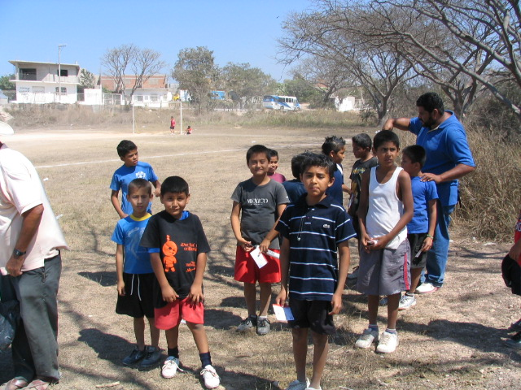

A youth soccer team in need of uniforms, Caopinole, Jalisco, Mexico, Feb. 21, 2009.

The Sports for the World’s Children Foundation (SWC), based in San Francisco, is a long time supporter of youth participation in sports locally and abroad. SWC’s mission is to facilitate the creation of ongoing, self-sustaining, quality sports programs for children with limited or no resources. Over the past eleven years, SWC has benefited more than 15,100 children, ages 5-18, by providing them with thousands of pounds of sports equipment and sports skills instruction and training through its “Communities Play” Program. SWC’s “Communities Play” Program has received past support from Alaska Airlines, Major League Baseball’s Baseball Tomorrow Fund, and the Kristi Yamaguchi Always Dream Foundation.

Interested individuals, teams, and/or sponsors can contact SWC for more information about the benefit softball tournament, their “Communities Play” sports equipment distribution/volunteer program to Mexico in November 2009, and/or to receive a DVD about their programs at swc@swcfoundation.org, (415) 566-3487.

# # #

